CS 6375

ASSIGNMENT 2: Neural Networks

Names of students in your group:

1. Ameya Kulkarni (ANK190006)

2. Yamini Thota (YRT190003)

Number of free late days used: ___0_________________

Note: You are allowed a **total** of 4 free late days for the **entire semester**. You can use at most 2 for each assignment. After that, there will be a penalty of 10% for each late day.

Please list clearly all the sources/references that you have used in this assignment.

- We haven’t used any resources directly.

Part 1:

* 1. Revisiting Backpropagation Algorithm

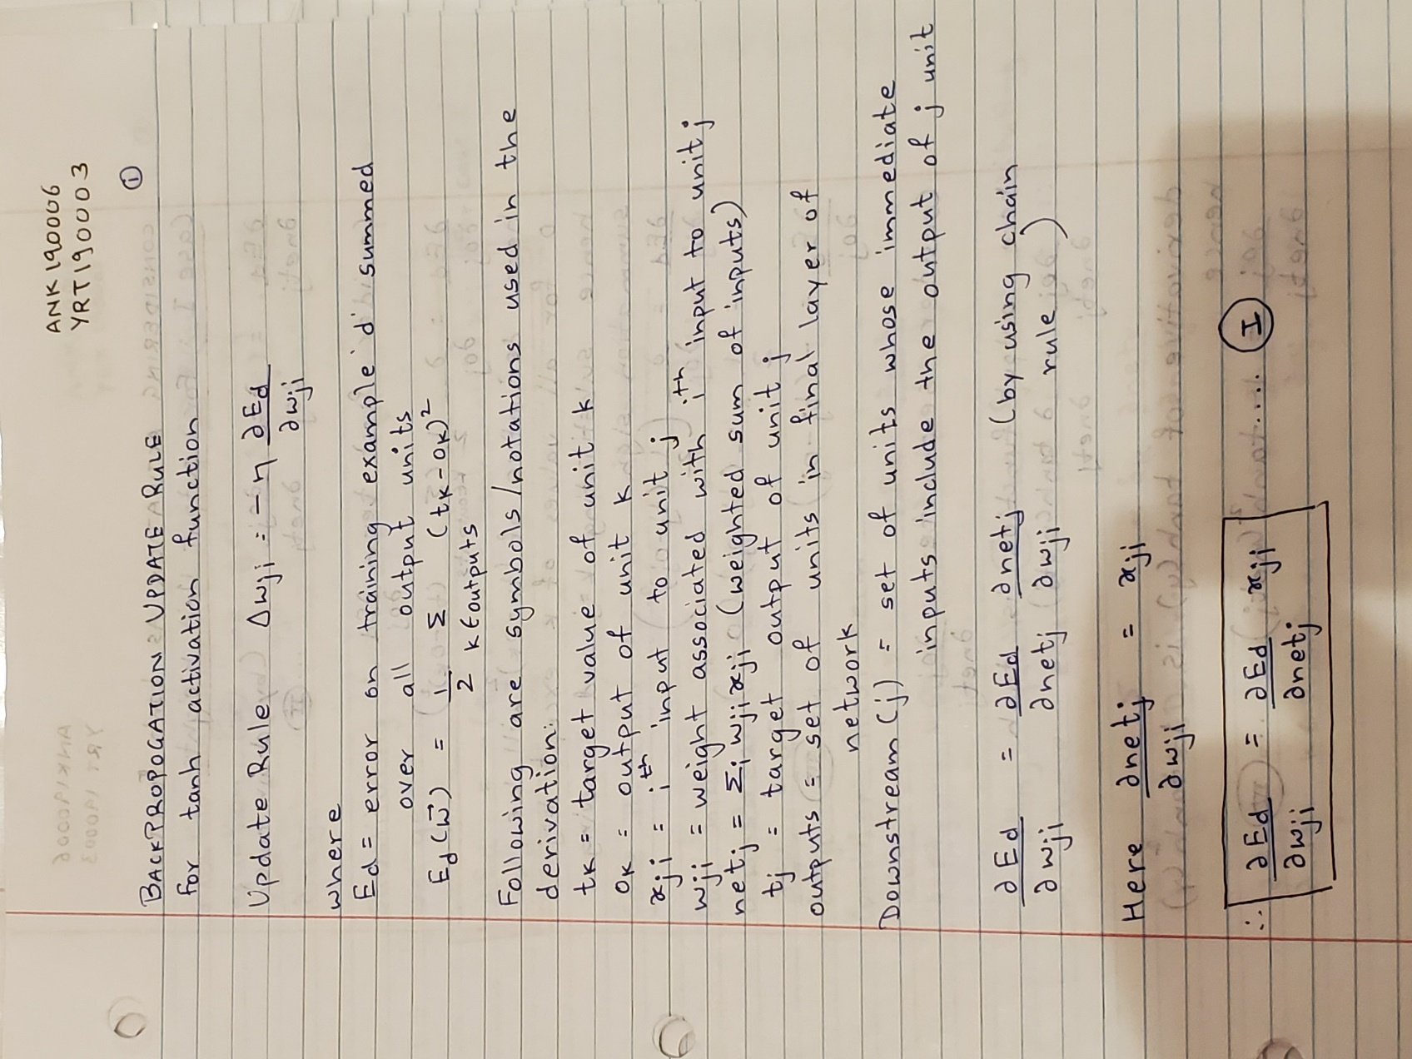

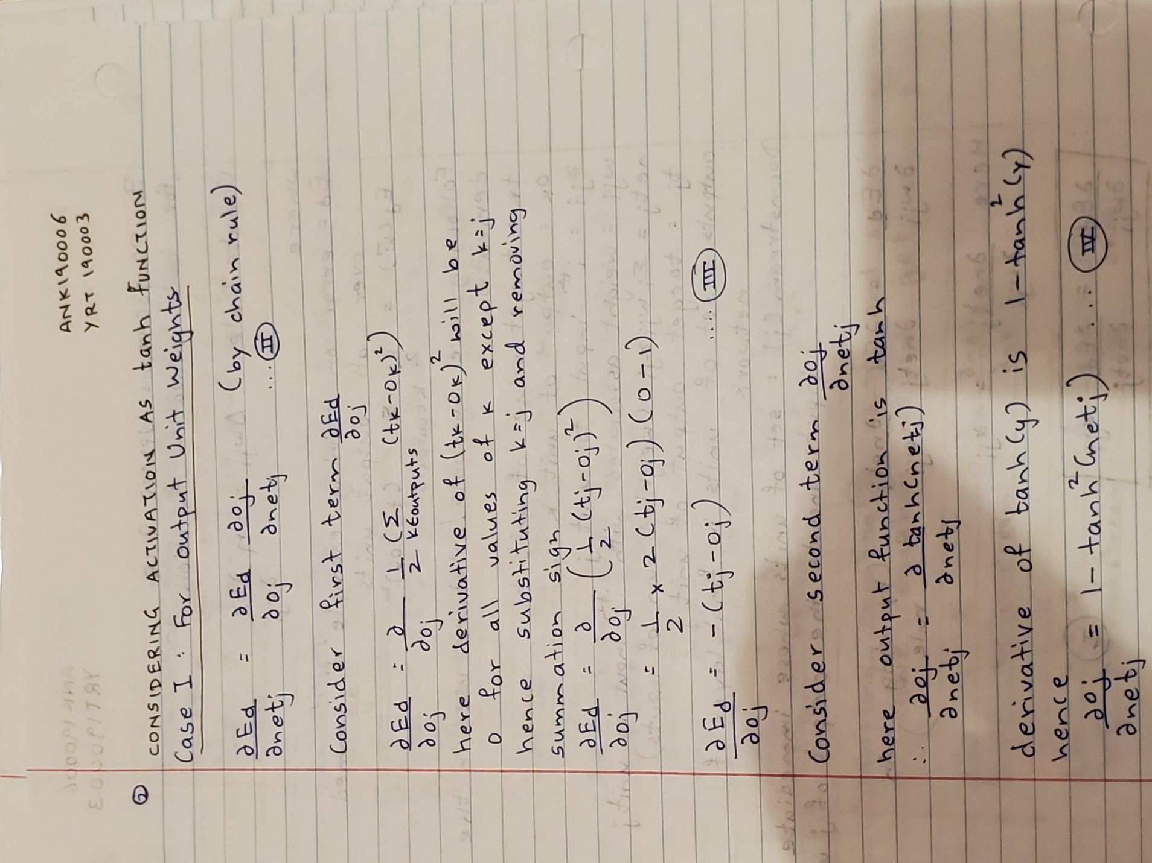



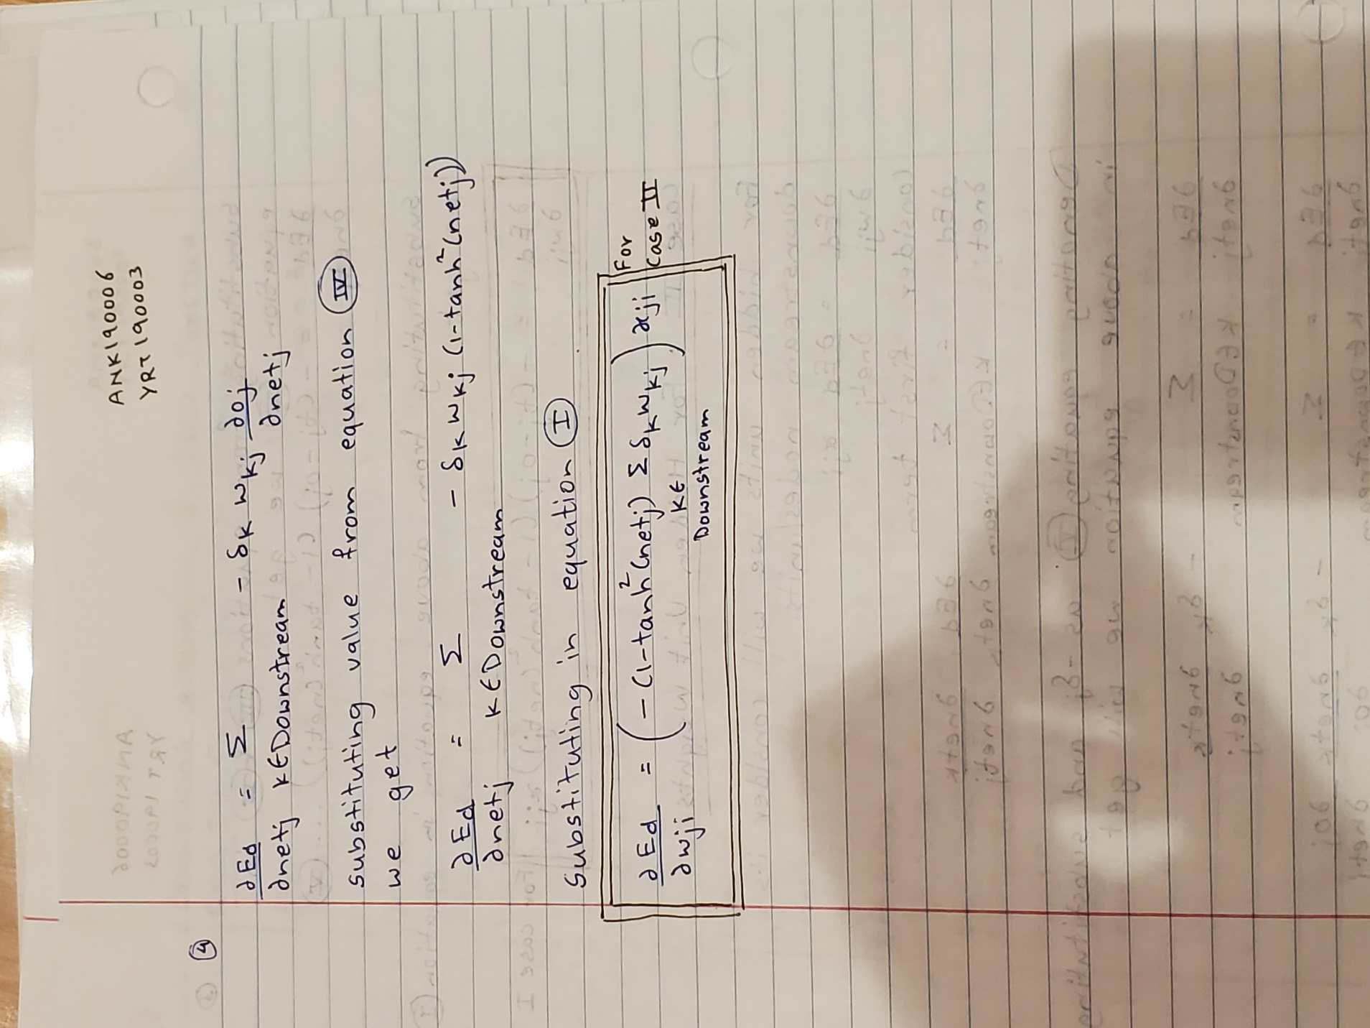

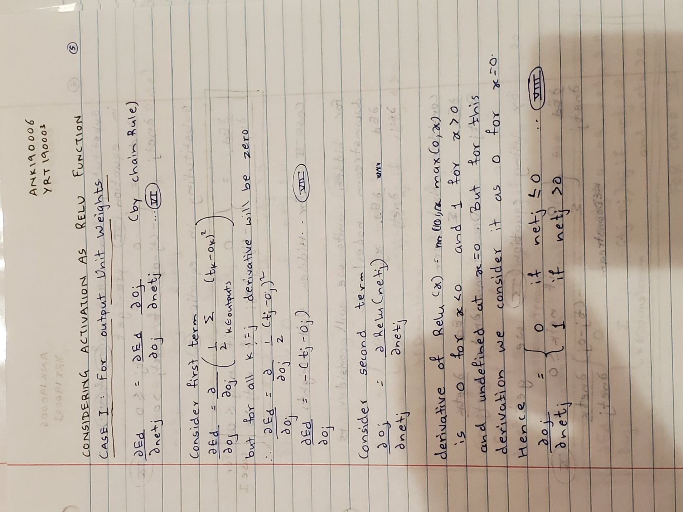

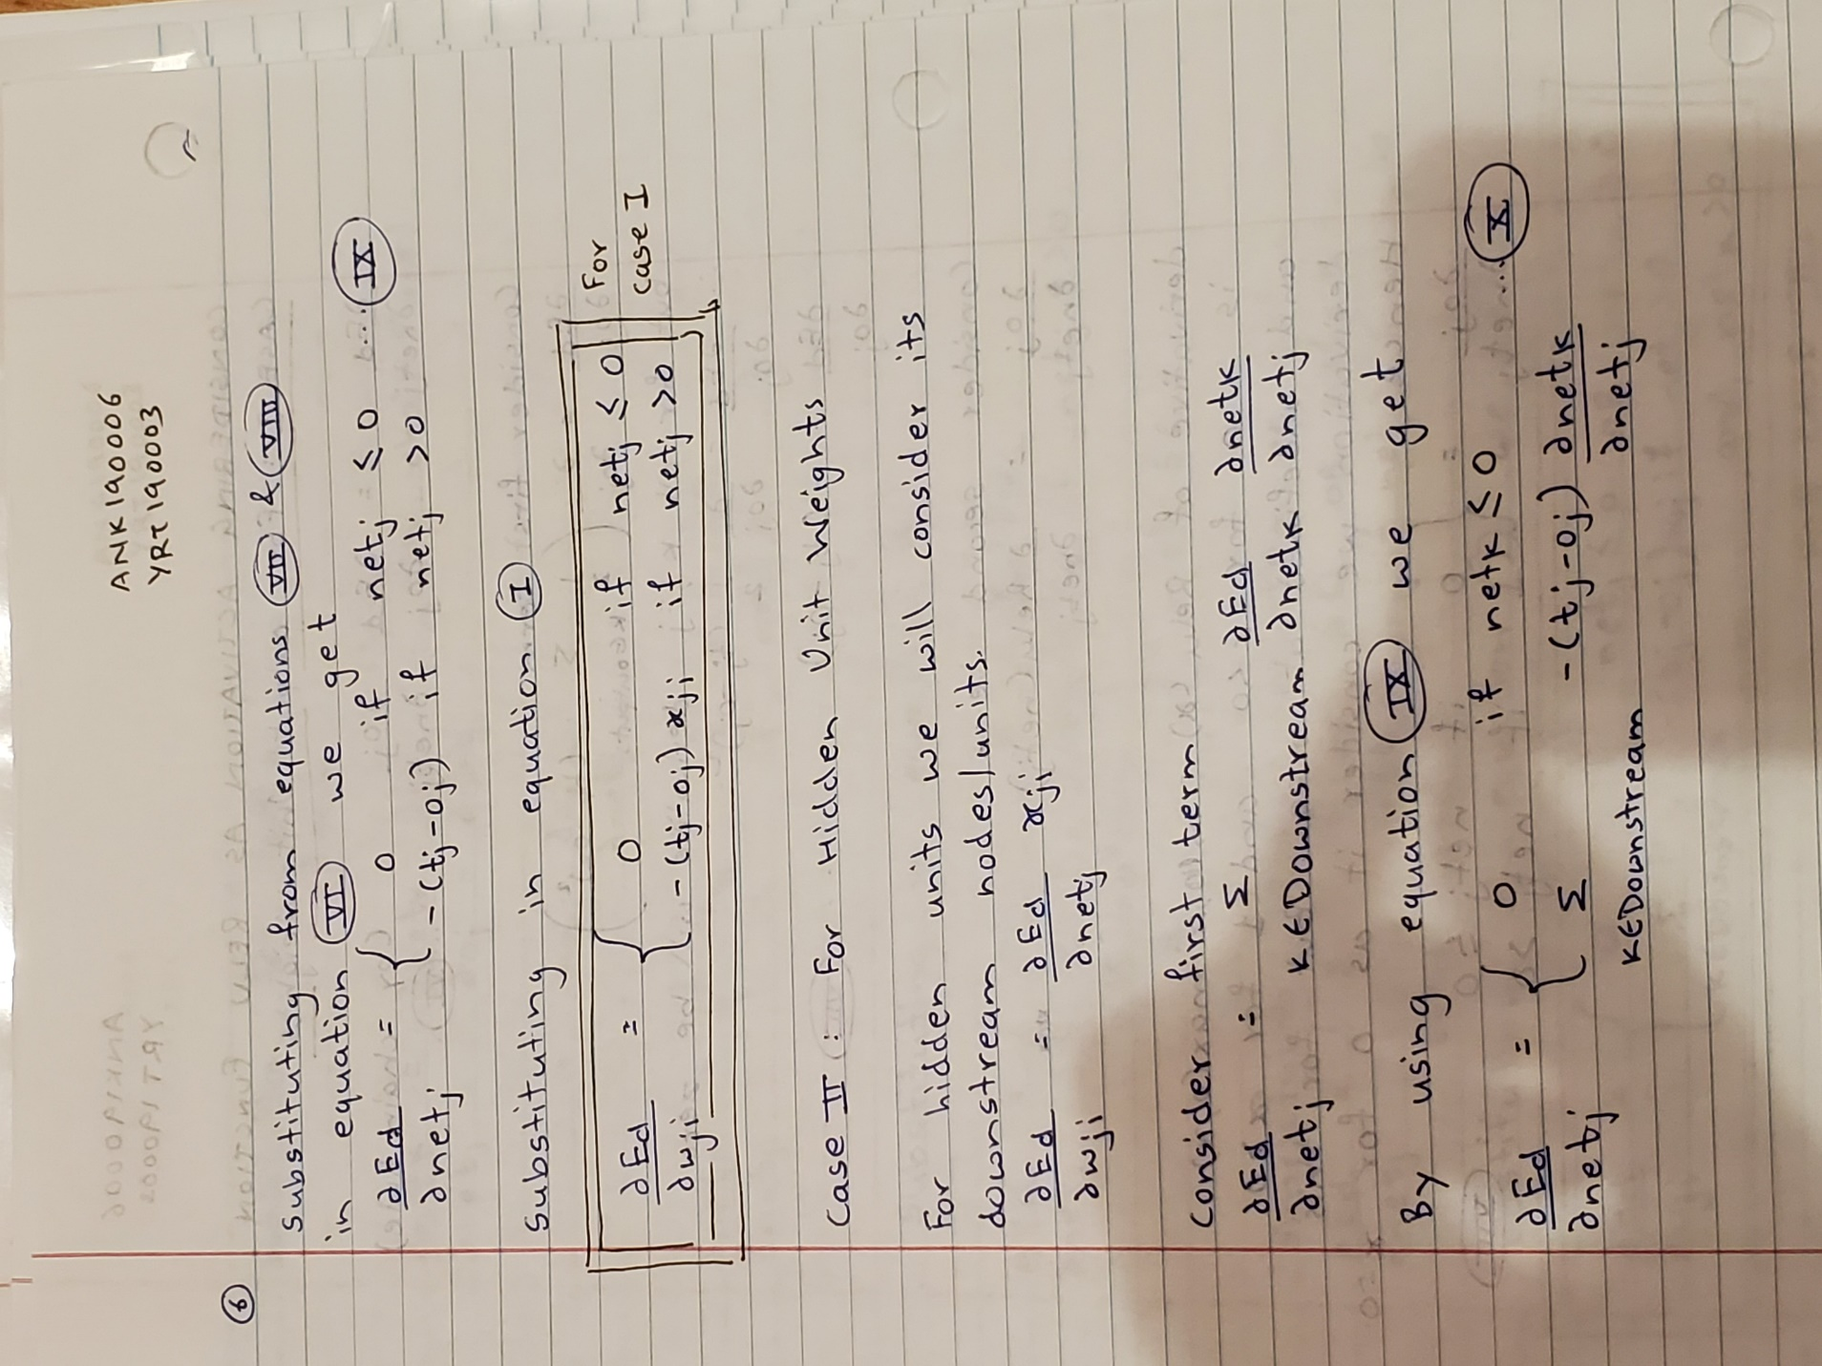

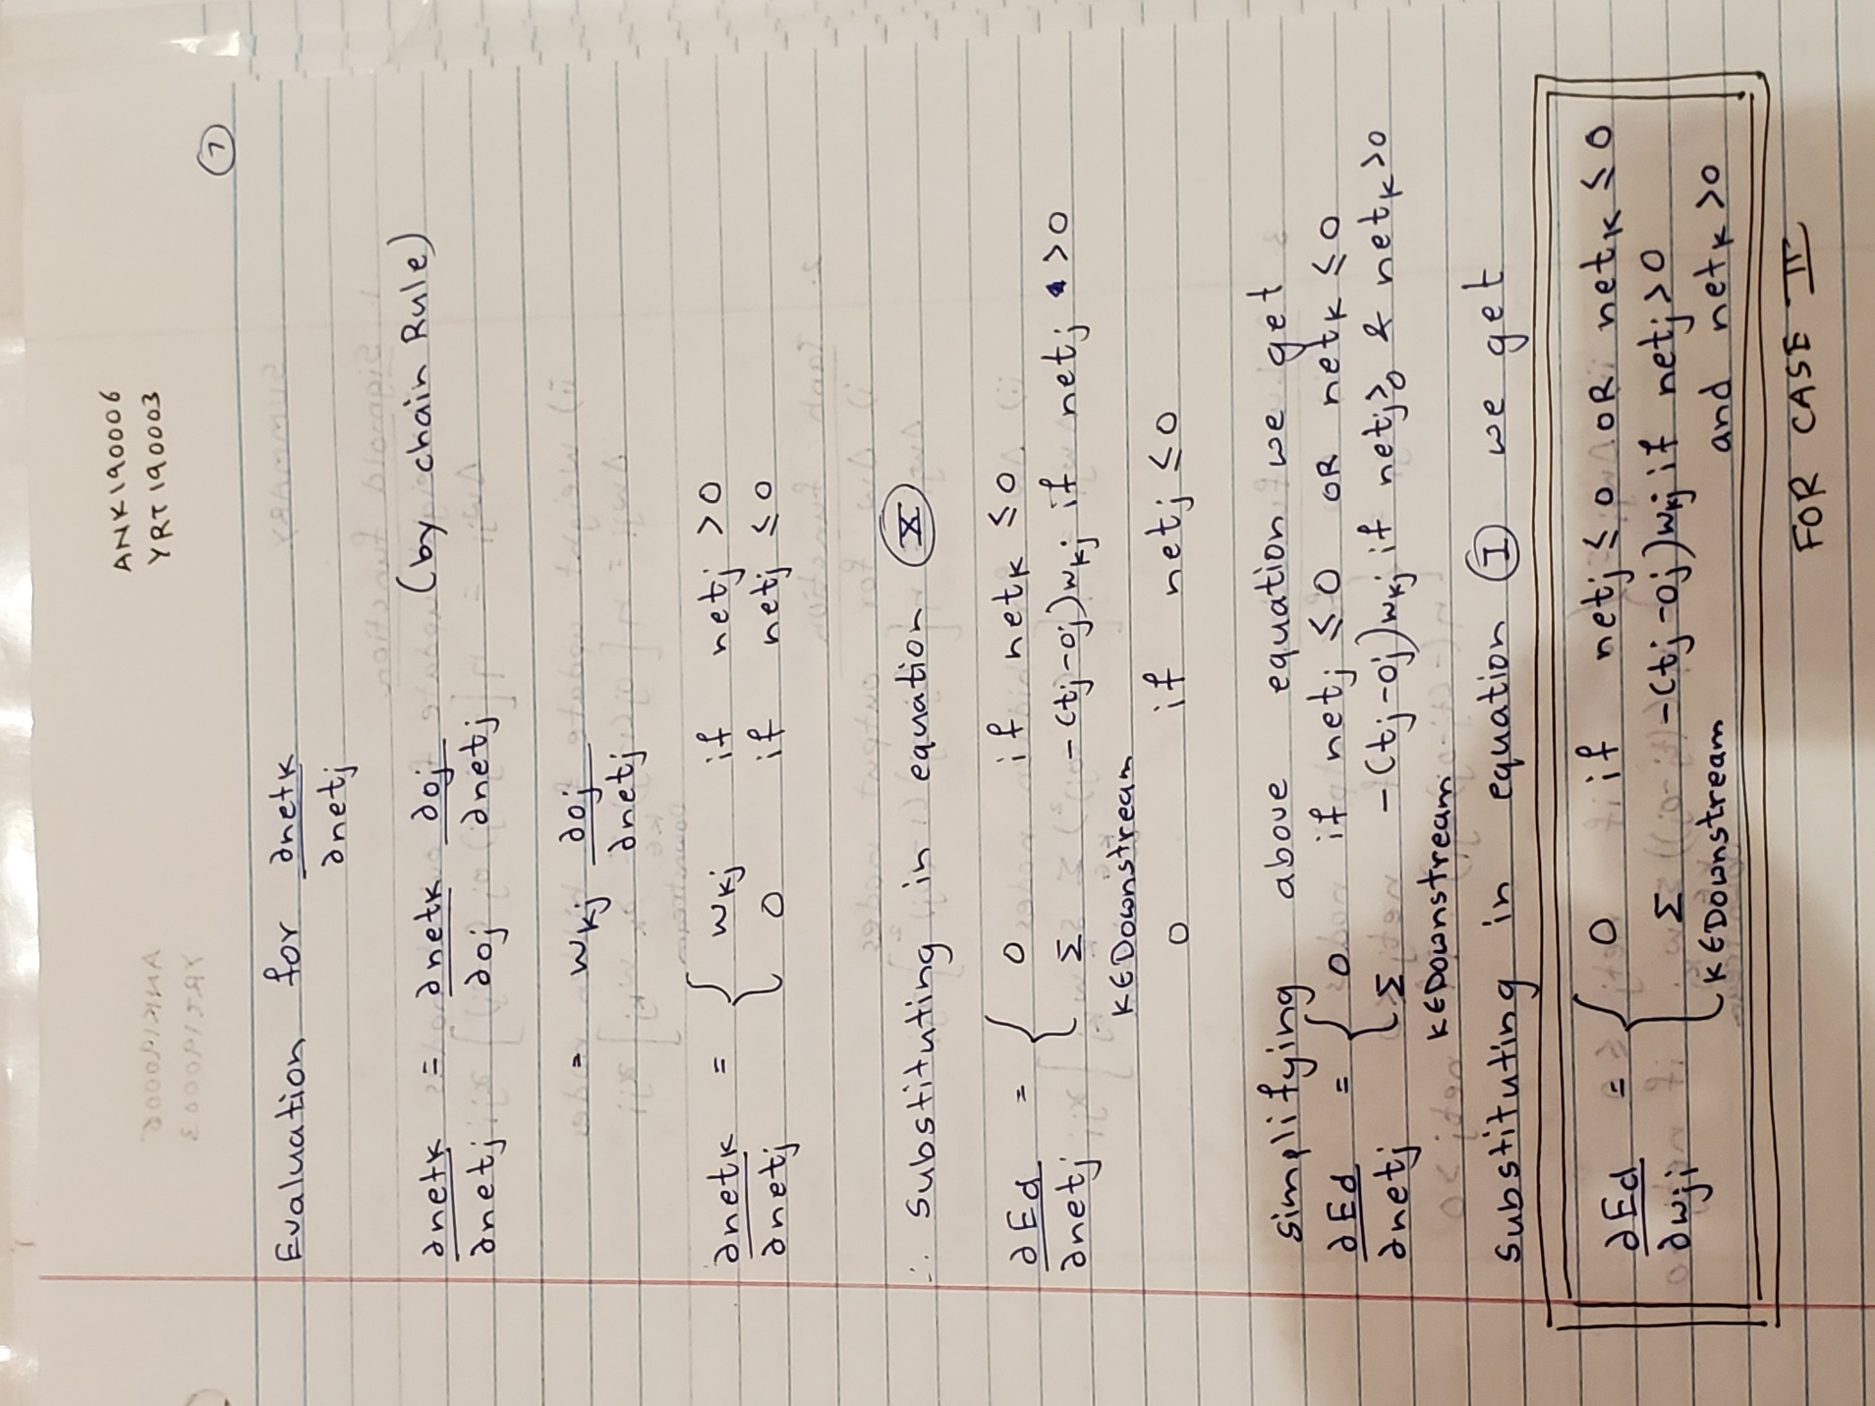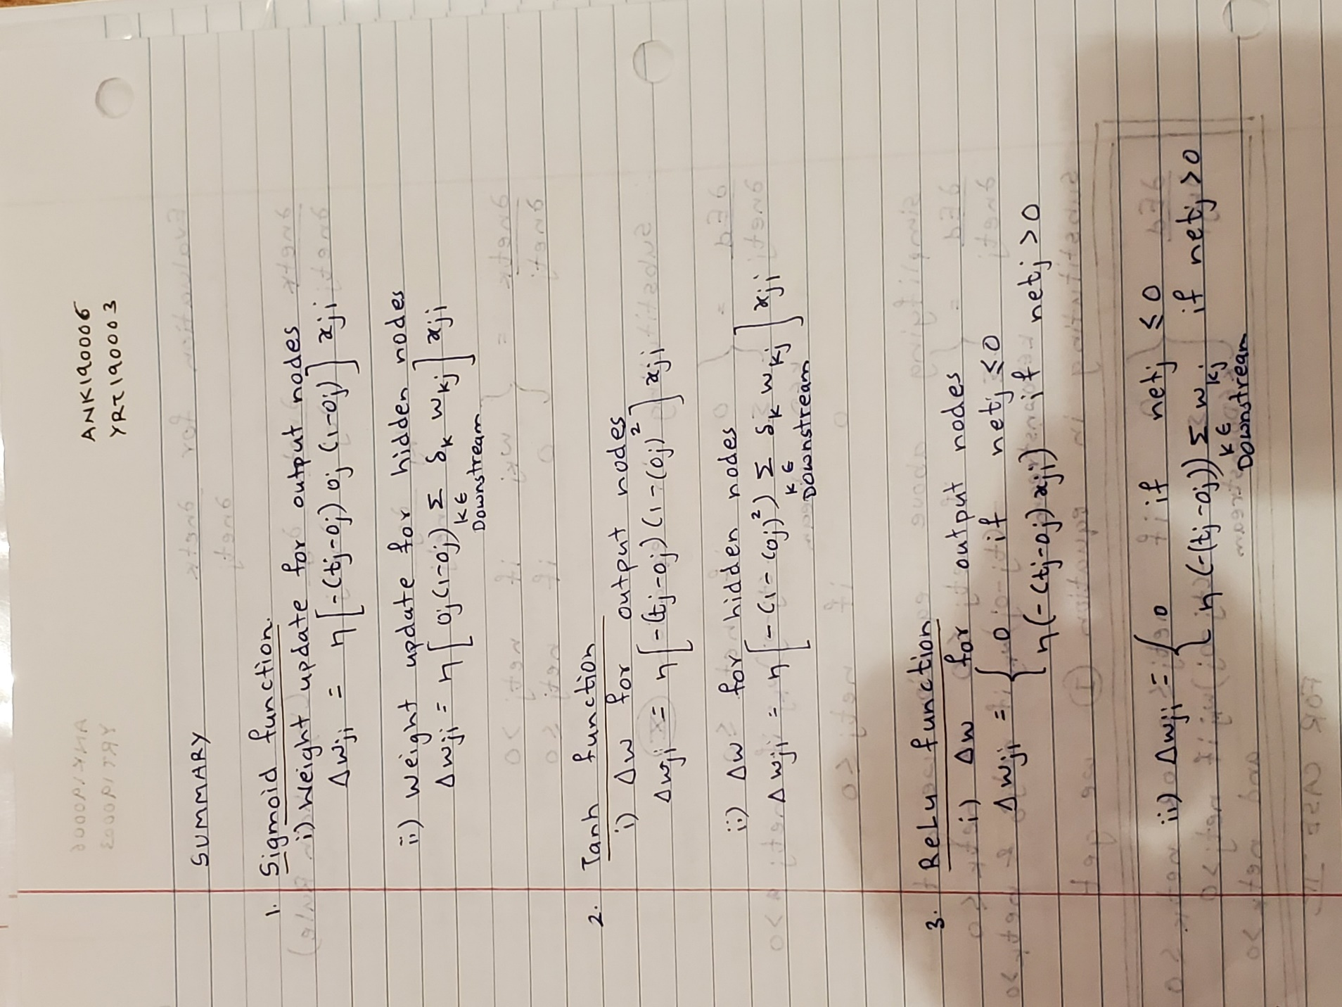

* 1. Gradient Descent

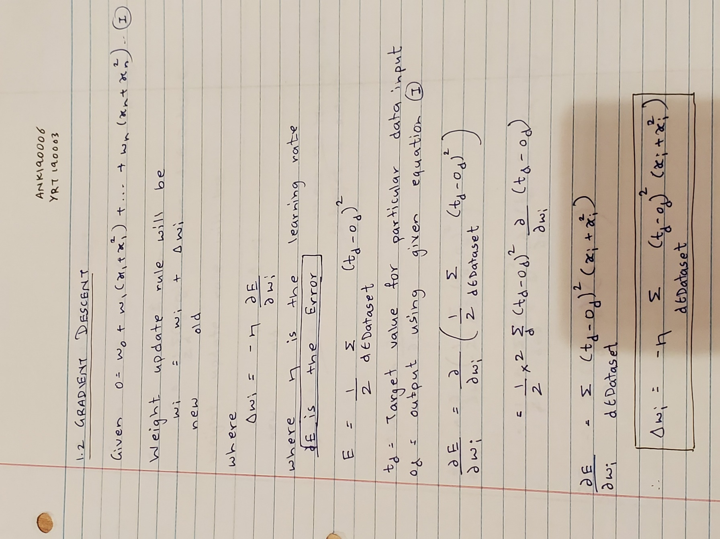

* 1. Comparing Activation Function

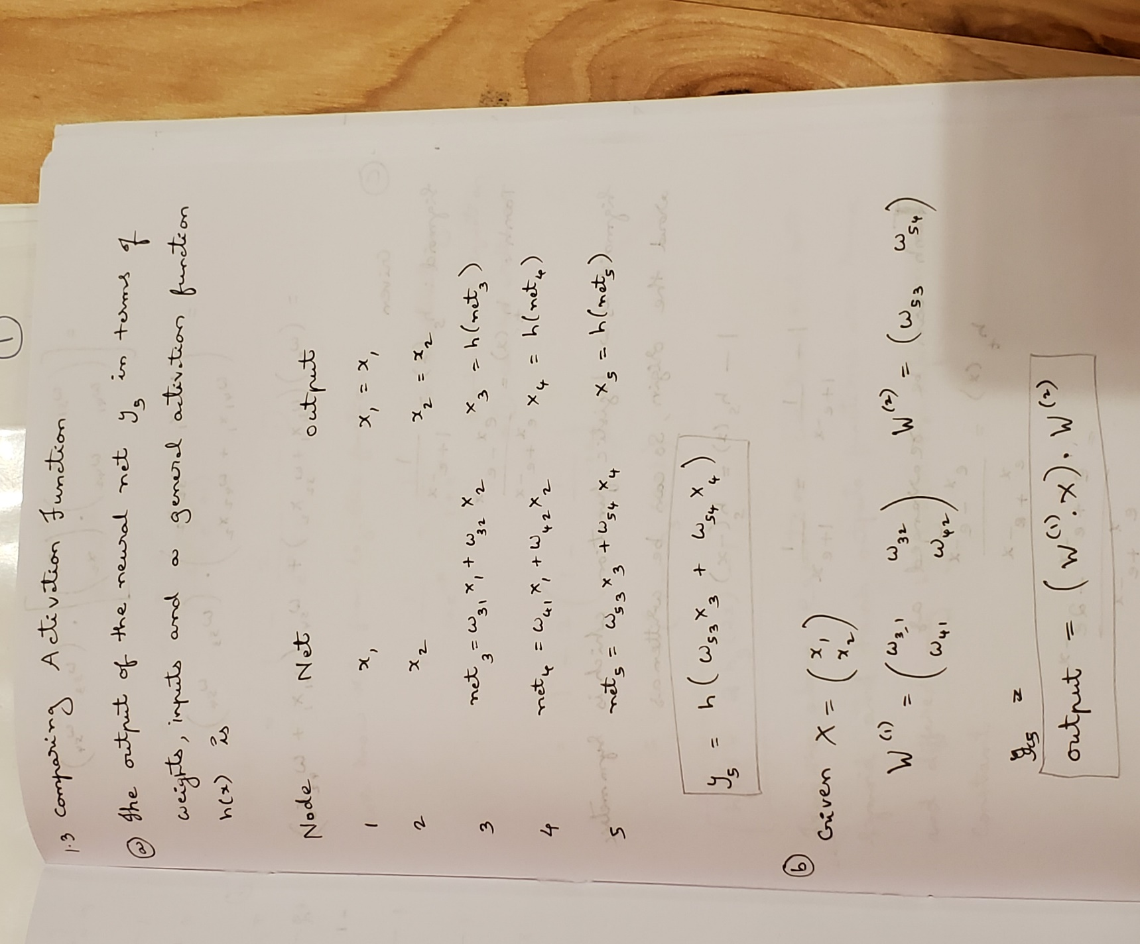

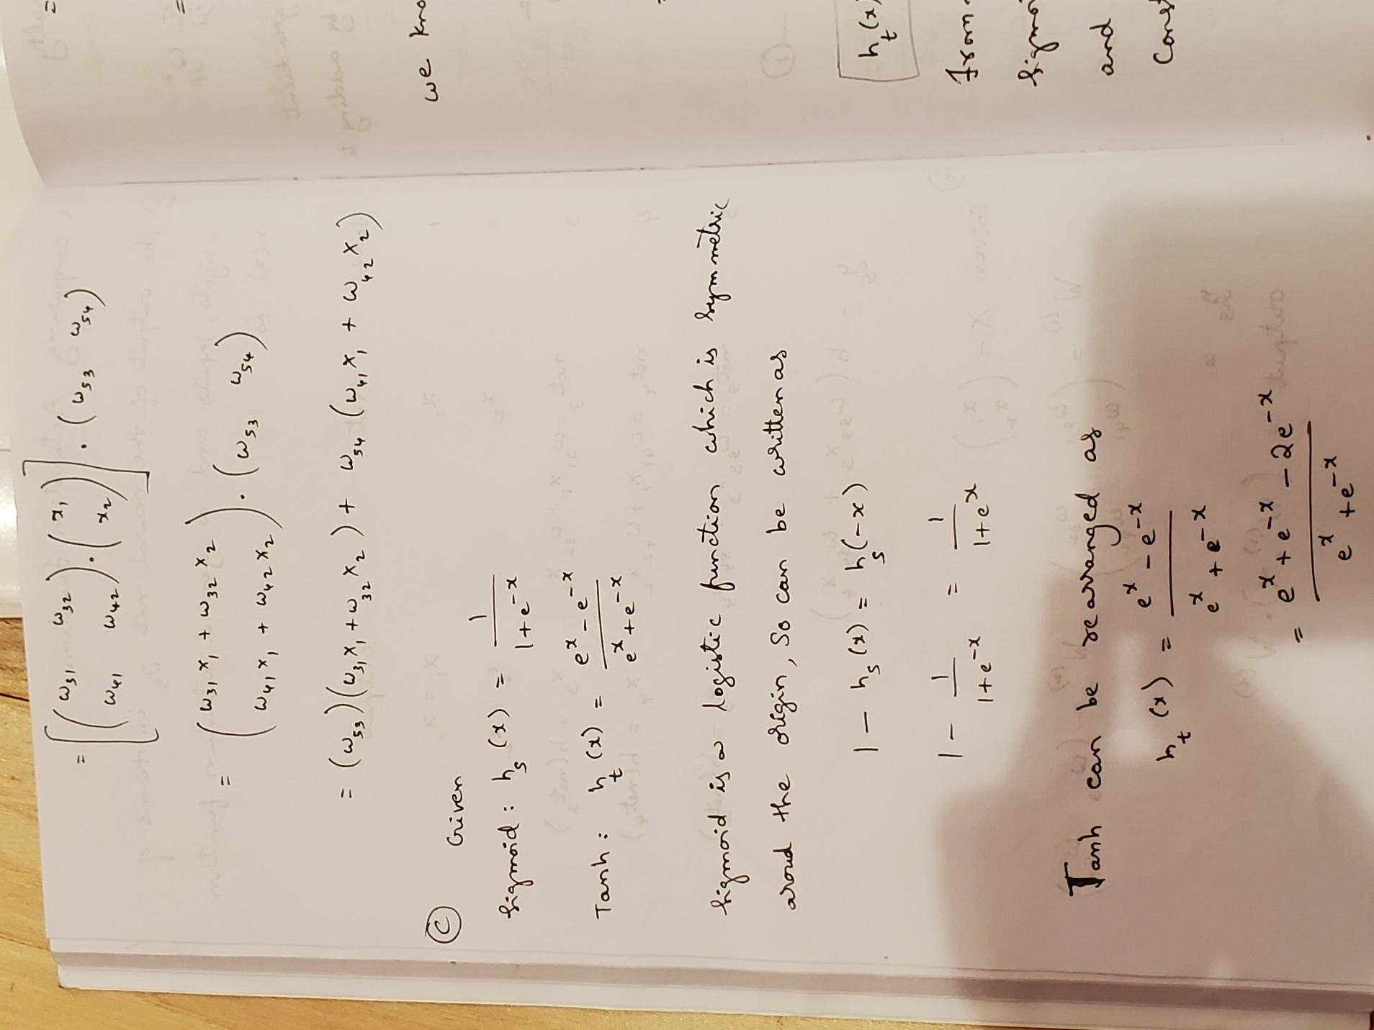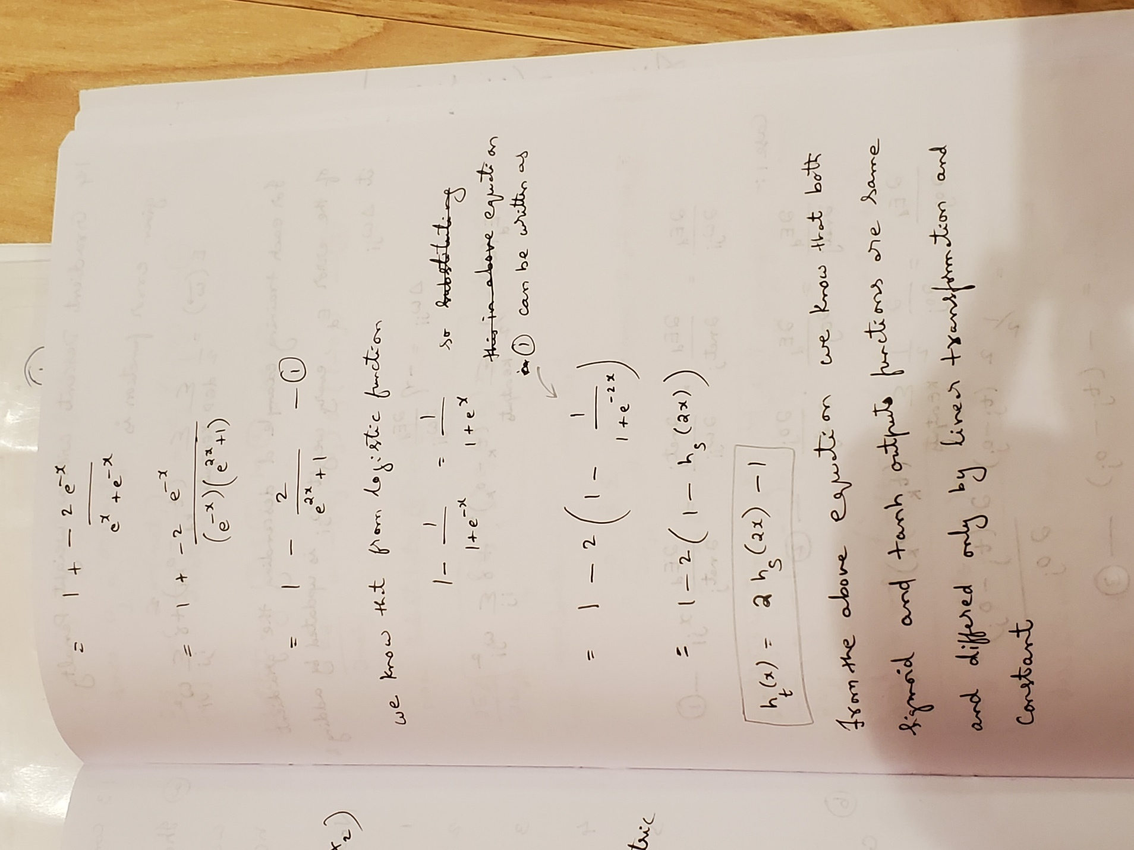

* 1. Gradient Descent with a Weight Penalty

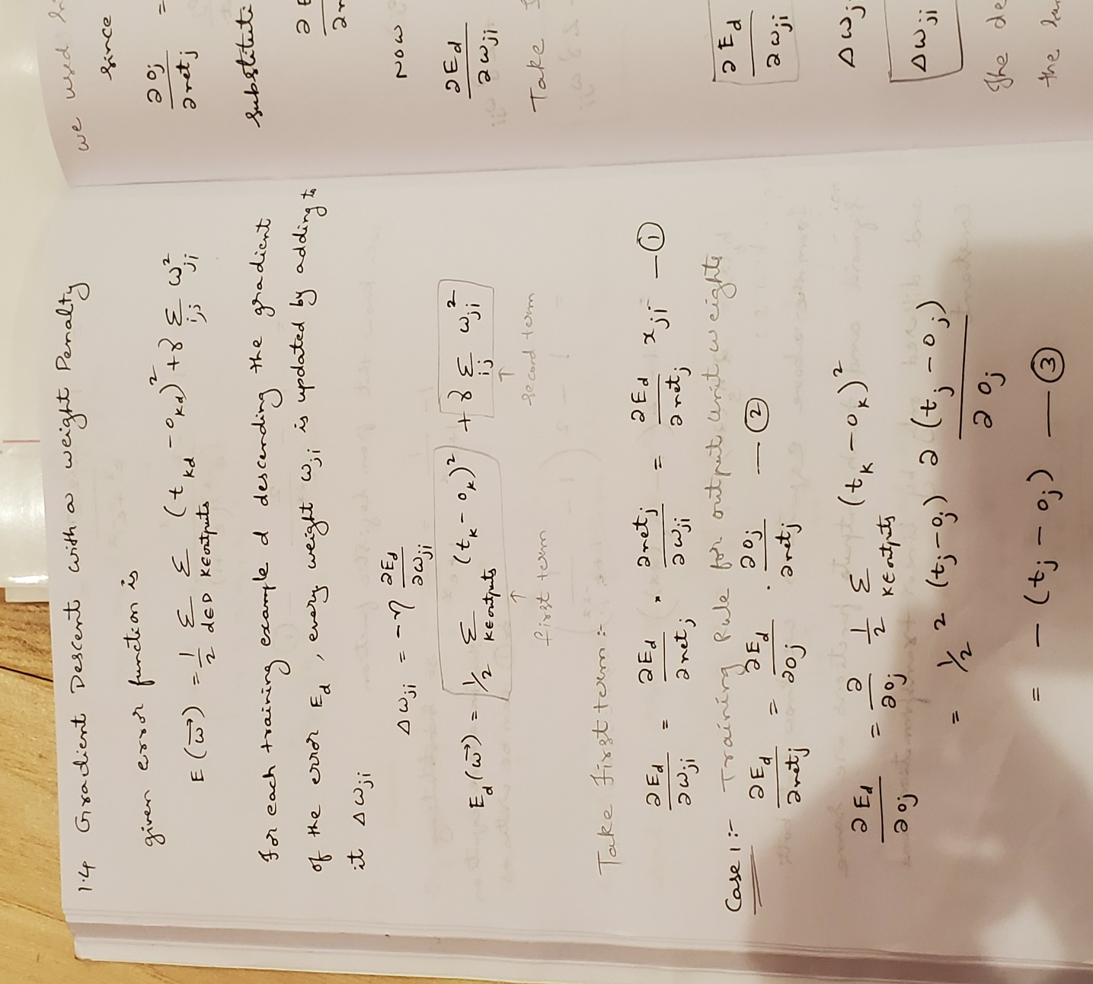

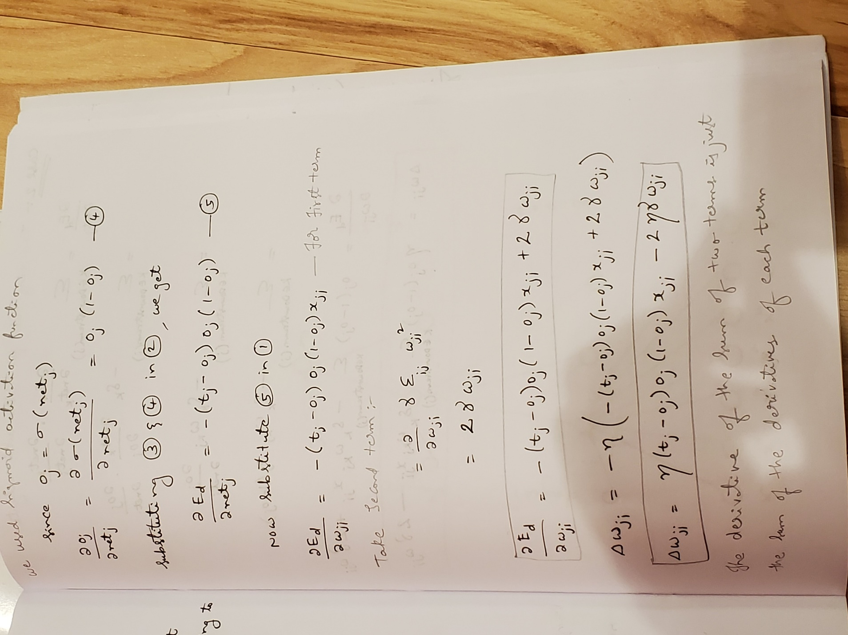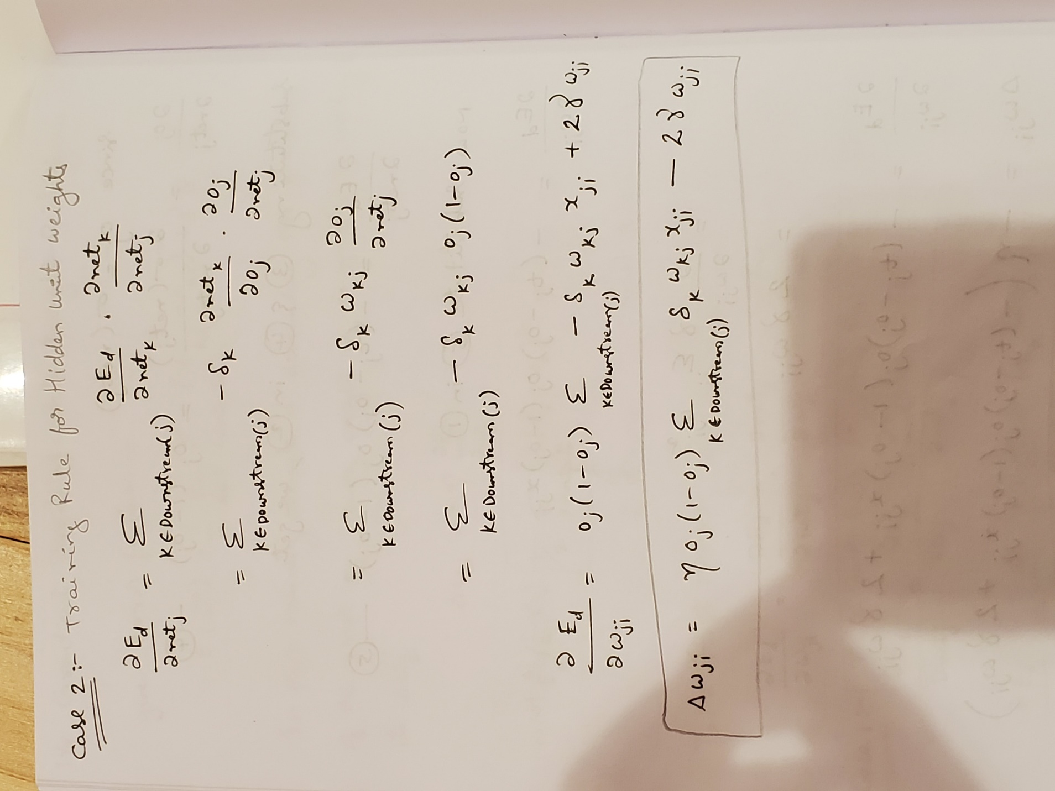

Part 2:

Dataset used: <https://archive.ics.uci.edu/ml/machine-learning-databases/wine-quality/> [winequality-red.csv](https://archive.ics.uci.edu/ml/machine-learning-databases/wine-quality/winequality-red.csv)

Note: For the purpose of code execution you can download the dataset from above location or else use the file which is already present.

Input features before pre-processing:

1 - fixed acidity  
2 - volatile acidity  
3 - citric acid  
4 - residual sugar  
5 - chlorides  
6 - free sulfur dioxide  
7 - total sulfur dioxide  
8 - density  
9 - pH  
10 - sulphates  
11 – alcohol

output feature: quality

Pre-processing activities includes:

- We don’t have any rows with null values.

- We don’t have any redundant rows, verified this using “drop_duplicates()”

- We applied Min-Max normalization on alcohol, pH, total Sulphur dioxide, quality features.

- We applied standardization on normalized total Sulphur dioxide and residual sugar.

- We removed fixed acidity, citric acid as it is dependent on pH and free sulfur dioxide which is dependent on total sulfur dioxide.

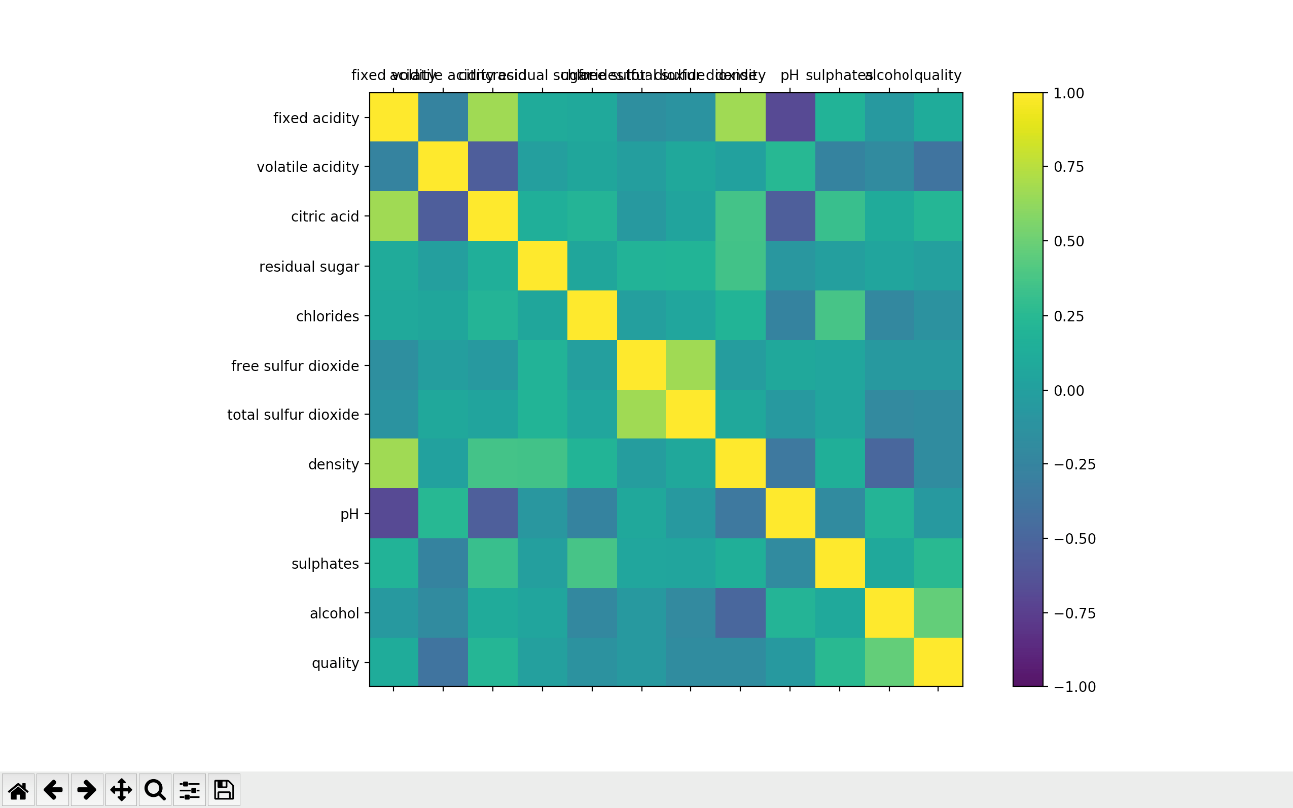

Fig 1: correlation matrix

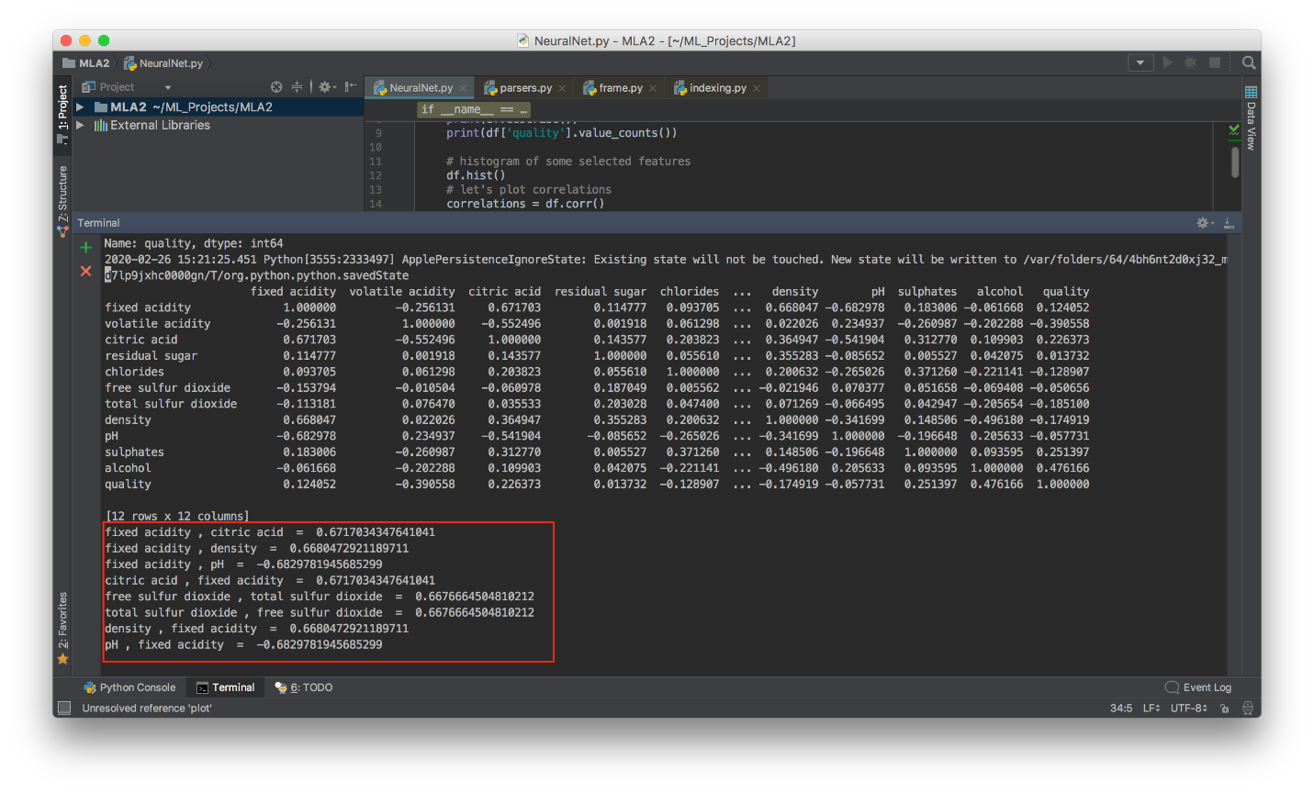

Fig 2 : features with Correlation greater then 0.65

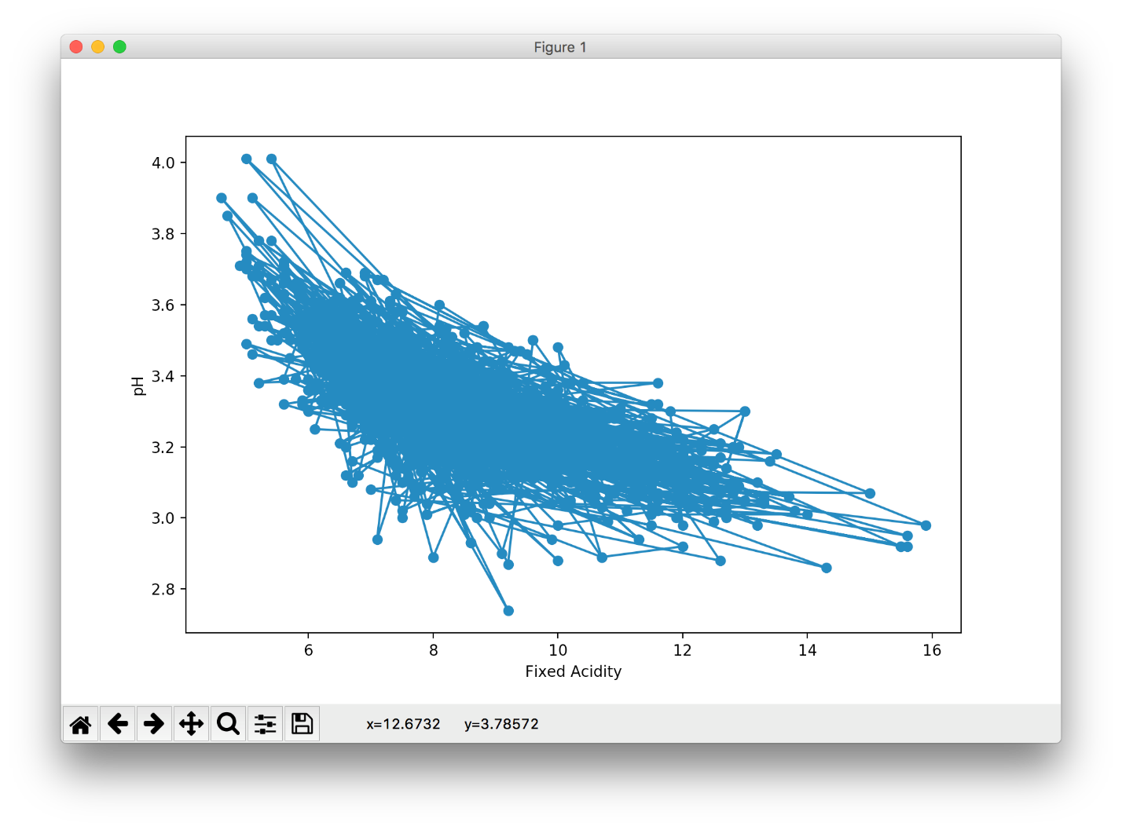

Fig 3: graph for one of the dependent features (pH vs Fixed acidity)

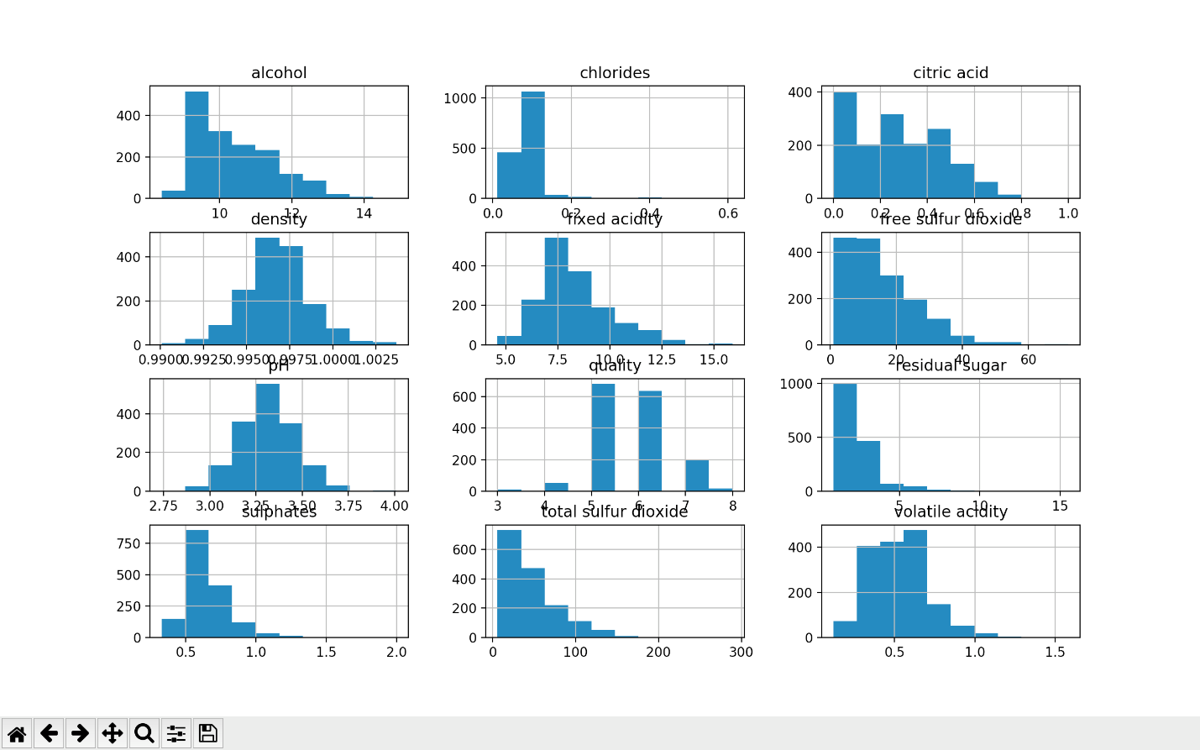

Fig 4: Features with respective to output(quality)

Input features after pre-processing:

1 - residual sugar  
2 - chlorides  
3 - total sulfur dioxide  
4 - density  
5 - pH  
6 - sulphates  
7 – alcohol

8 - volatile acidity

output feature: quality

Our Neural Network:

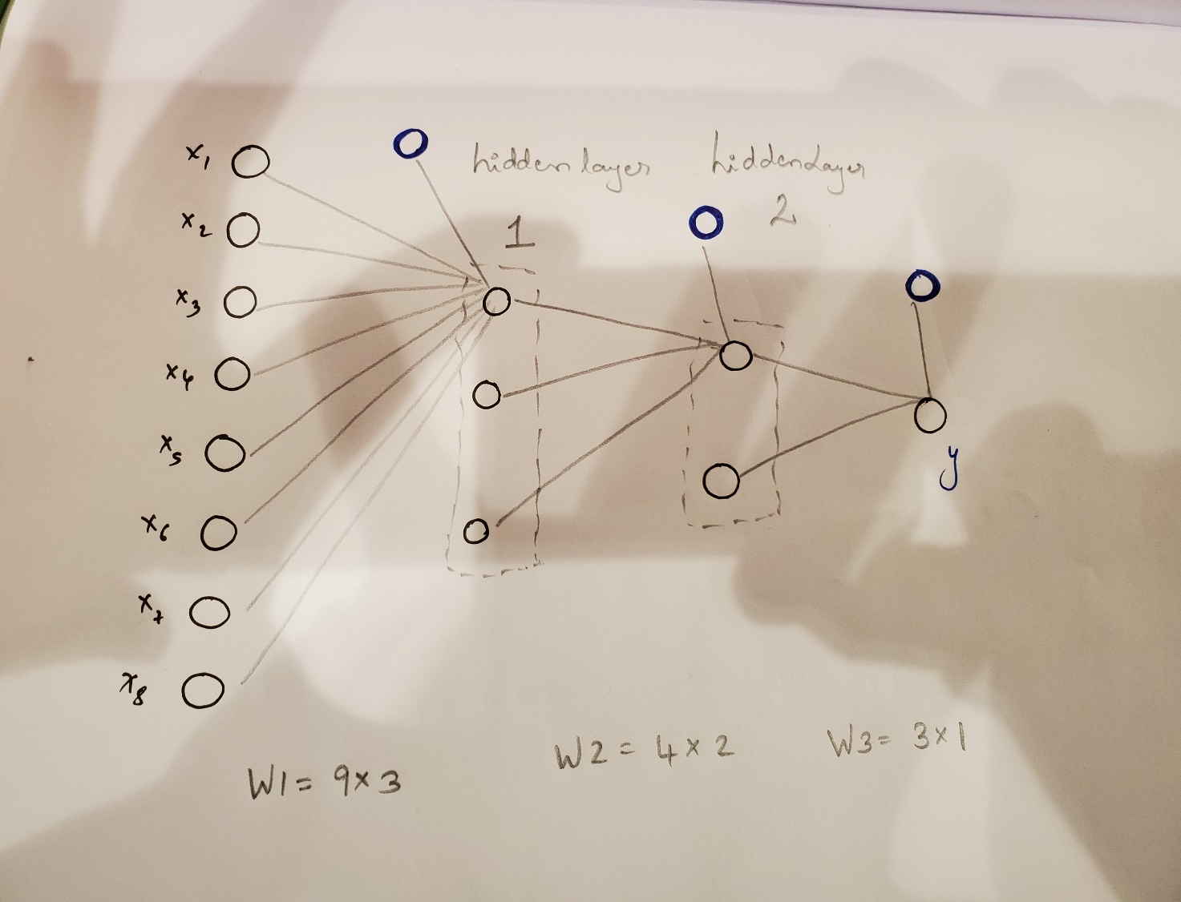

Fig 5

Observations:

How we got below observations:

- We ran our code with epoch range from 1000 to 1 reducing epoch by 20% every time for each activation function.

- For each epoch we changed the learning rate from 0.001 to 0.010 with a step of 0.001.

- We got total number of 270 observations for each activation function.

- On that we applied sorting to get a range of MSE on training data. Below tables have sample of 30 rows.

- We feel that highlighted rows can be the best values of epoch and learning rates.

Recording were taking with same starting weights for Sigmoid:

|  |  |  |  |  |
| --- | --- | --- | --- | --- |
| Activation | Epochs | Learning Rate | MSE Training Data | MSE Testing data |
| sigmoid | 1000 | 0.001 | 16.38573886 | 4.457954312 |
| sigmoid | 1000 | 0.002 | 16.38573886 | 4.457954312 |
| sigmoid | 1000 | 0.003 | 16.38573886 | 4.457954312 |
| sigmoid | 1000 | 0.004 | 16.38573886 | 4.457954312 |
| sigmoid | 1000 | 0.005 | 16.38573886 | 4.457954312 |
| sigmoid | 1000 | 0.006 | 16.38573886 | 4.457954312 |
| sigmoid | 800 | 0.001 | 16.38573886 | 4.457954312 |
| sigmoid | 800 | 0.002 | 16.38573886 | 4.457954312 |
| sigmoid | 800 | 0.003 | 16.38573886 | 4.457954312 |
| sigmoid | 800 | 0.004 | 16.38573886 | 4.457954312 |
| sigmoid | 800 | 0.005 | 16.38573886 | 4.457954312 |
| sigmoid | 800 | 0.006 | 16.38573886 | 4.457954312 |
| sigmoid | 640 | 0.001 | 16.38573886 | 4.457954312 |
| sigmoid | 640 | 0.002 | 16.38573886 | 4.457954312 |
| sigmoid | 640 | 0.003 | 16.38573886 | 4.457954312 |
| sigmoid | 640 | 0.004 | 16.38573886 | 4.457954312 |
| sigmoid | 640 | 0.005 | 16.38573886 | 4.457954312 |
| sigmoid | 640 | 0.006 | 16.38573886 | 4.457954312 |
| sigmoid | 512 | 0.001 | 16.38573886 | 4.457954312 |
| sigmoid | 512 | 0.002 | 16.38573886 | 4.457954312 |
| sigmoid | 512 | 0.003 | 16.38573886 | 4.457954312 |
| sigmoid | 512 | 0.004 | 16.38573886 | 4.457954312 |
| sigmoid | 512 | 0.005 | 16.38573886 | 4.457954312 |
| Sigmoid | 512 | 0.006 | 16.38573886 | 4.457954312 |
| Sigmoid | 409 | 0.001 | 16.38573886 | 4.457954312 |
| Sigmoid | 409 | 0.002 | 16.38573886 | 4.457954312 |
| Sigmoid | 409 | 0.003 | 16.38573886 | 4.457954312 |
| Sigmoid | 409 | 0.004 | 16.38573886 | 4.457954312 |
| Sigmoid | 409 | 0.005 | 16.38573886 | 4.457954312 |

Recording were taking with same starting weights for Tanh:

|  |  |  |  |  |
| --- | --- | --- | --- | --- |
| Activation | Epochs | Learning Rate | MSE Training Data | MSE Testing data |
| tanh | 1000 | 0.001 | 16.92344019 | 3.928099405 |
| tanh | 800 | 0.001 | 16.92344019 | 3.928099373 |
| tanh | 640 | 0.001 | 16.92344019 | 3.928098724 |
| tanh | 512 | 0.001 | 16.92344019 | 3.928091648 |
| tanh | 409 | 0.001 | 16.92344026 | 3.928154345 |
| tanh | 327 | 0.001 | 16.92344184 | 3.928360687 |
| tanh | 261 | 0.001 | 16.92346049 | 3.92901889 |
| tanh | 208 | 0.001 | 16.92359202 | 3.925636489 |
| tanh | 166 | 0.001 | 16.9241886 | 3.922734162 |
| tanh | 132 | 0.001 | 16.92616488 | 3.918186721 |
| tanh | 105 | 0.001 | 16.93123091 | 3.947963171 |
| tanh | 84 | 0.001 | 16.94054555 | 3.905834037 |
| tanh | 67 | 0.001 | 16.95819973 | 3.974636376 |
| tanh | 53 | 0.001 | 16.9853686 | 3.994101878 |
| tanh | 5 | 0.003 | 17.0064517 | 3.890391304 |
| tanh | 42 | 0.001 | 17.01594592 | 3.889513139 |
| tanh | 7 | 0.002 | 17.04829774 | 3.887620746 |
| tanh | 33 | 0.001 | 17.07430378 | 4.044678084 |
| tanh | 26 | 0.001 | 17.11472983 | 3.887189829 |
| tanh | 20 | 0.001 | 17.18276538 | 3.889624415 |
| tanh | 16 | 0.001 | 17.24636326 | 3.893556736 |
| tanh | 12 | 0.001 | 17.33320985 | 3.900698525 |
| tanh | 3 | 0.004 | 17.3355027 | 3.900909203 |
| tanh | 9 | 0.001 | 17.52215981 | 4.234943178 |
| tanh | 7 | 0.001 | 17.62380346 | 4.273182432 |
| tanh | 2 | 0.007 | 18.36611586 | 4.045268222 |
| tanh | 327 | 0.002 | 18.90879363 | 4.710806298 |
| tanh | 2 | 0.008 | 22.35242625 | 5.759315265 |
| tanh | 9 | 0.002 | 26.05171955 | 5.598739721 |
| tanh | 512 | 0.002 | 32.12998929 | 8.524175983 |
| tanh | 4 | 0.004 | 33.02090897 | 8.769935241 |
| tanh | 2 | 0.006 | 41.40497644 | 9.049030452 |
| tanh | 2 | 0.009 | 44.94732678 | 12.01398742 |
| tanh | 12 | 0.002 | 46.34030086 | 12.38888277 |
| tanh | 105 | 0.002 | 60.95085365 | 13.59683325 |
| tanh | 261 | 0.002 | 62.76998103 | 14.02443023 |
| tanh | 20 | 0.002 | 63.40174059 | 16.9404614 |
| tanh | 640 | 0.002 | 63.97113381 | 17.09137088 |
| tanh | 2 | 0.004 | 67.33615486 | 17.98221002 |
| tanh | 7 | 0.003 | 67.62443465 | 15.16806584 |
| tanh | 2 | 0.01 | 73.05191351 | 19.49176817 |
| tanh | 3 | 0.003 | 76.93885732 | 17.37133592 |
| tanh | 1 | 0.01 | 77.67544904 | 20.7099448 |
| tanh | 26 | 0.002 | 78.69932179 | 17.78890156 |
| tanh | 261 | 0.005 | 88.42745639 | 23.53433837 |

Recording were taking with same starting weights for Relu:

|  |  |  |  |  |
| --- | --- | --- | --- | --- |
| Activation | Epochs | Learning Rate | MSE Training Data | MSE Testing data |
| Relu | 1000 | 0.001 | 193.66 | 49.4 |
| Relu | 1000 | 0.002 | 193.66 | 49.4 |
| Relu | 1000 | 0.003 | 193.66 | 49.4 |
| Relu | 1000 | 0.004 | 193.66 | 49.4 |
| Relu | 1000 | 0.005 | 193.66 | 49.4 |
| Relu | 1000 | 0.006 | 193.66 | 49.4 |
| Relu | 1000 | 0.007 | 193.66 | 49.4 |
| Relu | 1000 | 0.008 | 193.66 | 49.4 |
| Relu | 1000 | 0.009 | 193.66 | 49.4 |
| Relu | 1000 | 0.01 | 193.66 | 49.4 |
| Relu | 800 | 0.001 | 193.66 | 49.4 |
| Relu | 800 | 0.002 | 193.66 | 49.4 |
| Relu | 800 | 0.003 | 193.66 | 49.4 |
| Relu | 800 | 0.004 | 193.66 | 49.4 |
| Relu | 800 | 0.005 | 193.66 | 49.4 |
| Relu | 800 | 0.006 | 193.66 | 49.4 |
| Relu | 800 | 0.007 | 193.66 | 49.4 |
| Relu | 800 | 0.008 | 193.66 | 49.4 |
| Relu | 800 | 0.009 | 193.66 | 49.4 |
| Relu | 800 | 0.01 | 193.66 | 49.4 |
| Relu | 640 | 0.001 | 193.66 | 49.4 |
| Relu | 640 | 0.002 | 193.66 | 49.4 |
| Relu | 640 | 0.003 | 193.66 | 49.4 |
| Relu | 640 | 0.004 | 193.66 | 49.4 |
| Relu | 640 | 0.005 | 193.66 | 49.4 |
| Relu | 640 | 0.006 | 193.66 | 49.4 |
| Relu | 640 | 0.007 | 193.66 | 49.4 |
| Relu | 640 | 0.008 | 193.66 | 49.4 |
| Relu | 640 | 0.009 | 193.66 | 49.4 |
| Relu | 640 | 0.01 | 193.66 | 49.4 |

Below are the graphs for MSE vs iterations.

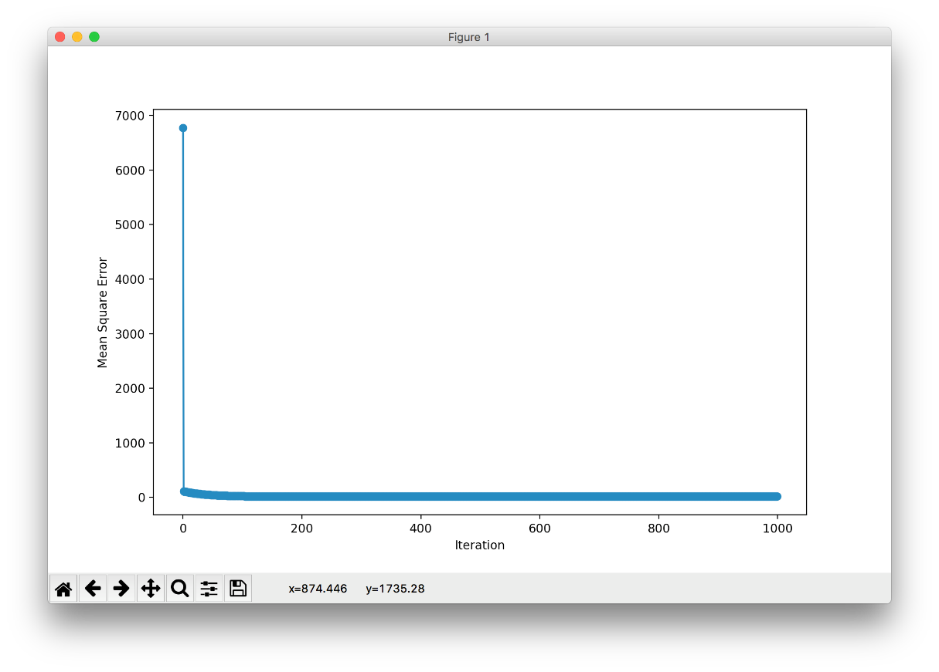

Fig 6 : Relu activation function

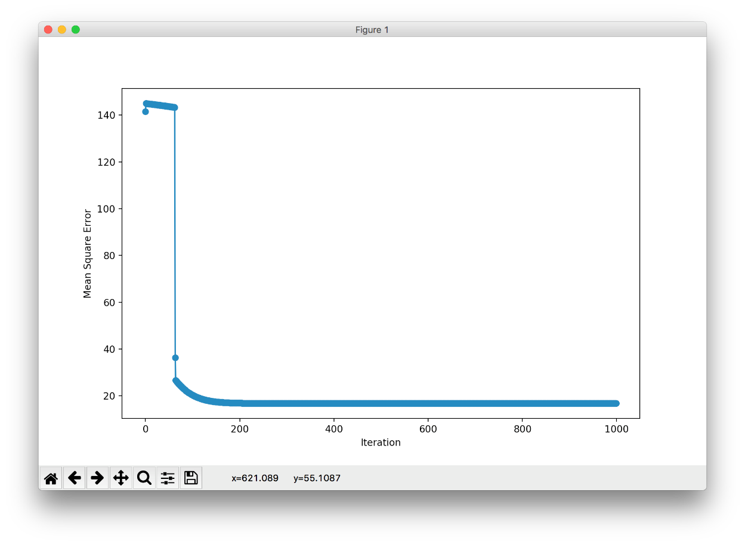

Fig 7: tanh activation function

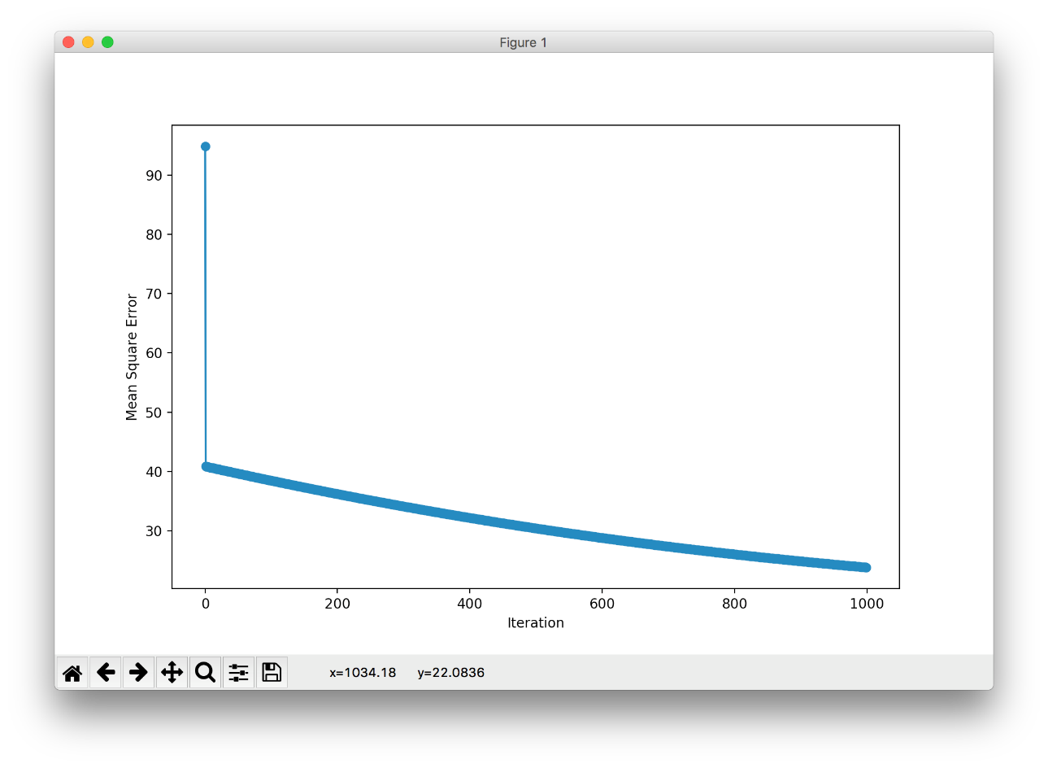

Fig 8: Sigmoid activation function

A brief report summarizing our results:

In our case tanh activation function performed well, we got low MSE for training and testing data.